COMP-4640: Intelligent & Interactive Systems
Lecture #5: Uninformed Search

Incremental Problem Formulation (The N-Queens Problem)

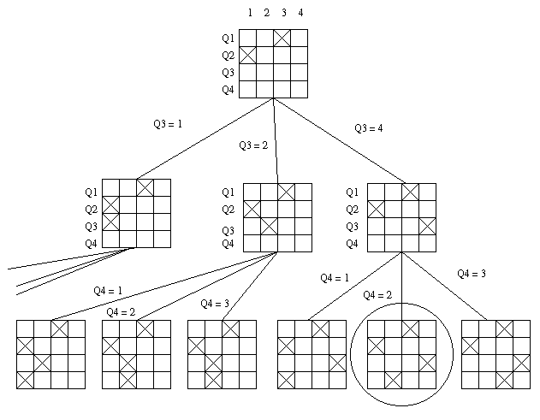

Problem Formation

Goal: A configuration where no queens can attack one another

Initial State: (Q1=3, Q2=1, Q3=__, Q4=__)

Operations: The queens can be assigned a value from the set {1, 2, 3, 4}

Path Cost: None

COMP-4640: Intelligent & Interactive Systems

Lecture #5

Constraint Satisfaction Search

- A constraint satisfaction problem (CSP) is a problem composed of variables and constraints. The objective is to assign values to variable in such a way that all of the constraints are satisfied.

- A CSP can more formally viewed as a triple <D,X,C> where:

- D represents a set of n domains

- X represents a set of n variables, each variable x_{i} takes it value from D_{i}

- C represents a set of constraints.

COMP-4640: Intelligent & Interactive Systems
Lecture #5

Constraint Satisfaction Search (cont.)

Consider the following CSP <X, D,C> where

- X = {E, F, G}

- D = {D_{E} = {e1, e2, e3}, D_{F} = {f1, f2, f3}, D_{G} = {g1, g2, g3}}

- C = {C₁, C₂, C₃} where

- C₁(E,F) = {<e1, f2>, <e1, f3>, <e2, f2>, <e3, f2>}
- C₂(E,G) = {<e2, g3>, <e3, g1>}
- C₃{F,G) = {<f2, g1>, <f2, g3>}

- The set of n-tuples that satisfy all of the constraints is known as the intent of the CSP, Π

- Given the above CSP, Π_{X,D,C} = {<e2, f2, g3>, <e3, f2, g1>)

COMP-4640: Intelligent & Interactive Systems

Lecture #5

Constraint Satisfaction Search (cont.)

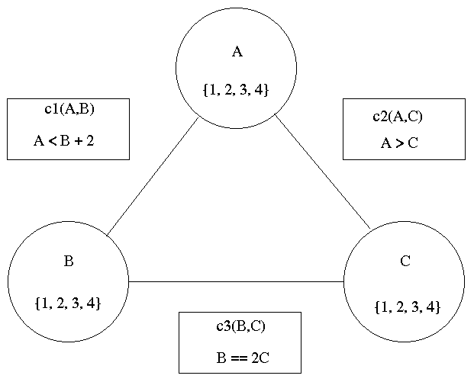

Incremental State Problem Formulation

Goal State: A set of assignments
<A=x,B=y,C=z> that satisfies
constraints c1, c2, and c3

Initial State: <A=__, B=__, C=__>

Operators: variable assignment

Path Cost: None

- Using the above problem formulation we can incrementally assign values to A, B, and C using chronological backtracking (depth-first search)

- In chronological backtracking, thrashing occurs frequently

COMP-4640: Intelligent & Interactive Systems
Lecture #5

Constraint Satisfaction Search (cont.)

- In the search for a solution to the above CSP, the depth-first search algorithm backtracked frequently in order to find alternative assignments for B (particularly when A=1). However, the value assignments to B were not the problem. The real culprit was the value assignment to A. This type of “wasteful” backtracking is known as thrashing.

- One method that can be used to reduce thrashing in backtrack search is known as arc revision

- Arc revision removes values from the domains of variables that cannot be used to solve a particular constraint

- For example, if we want to revise the domain of A using the domain of B, we will remove the values from domain A that cannot be use to solve constraint c1(A,B).

- Arc Consistency algorithms use arc revision to reduce the domains of a CSP to their minimum cardinality.

- This reduces the size of the search space as well as the amount of thrashing.

COMP-4640: Intelligent & Interactive Systems
Lecture #5

Constraint Satisfaction Search (cont.)

Arc consistency reduces the search space from 64 candidate solutions to 12.

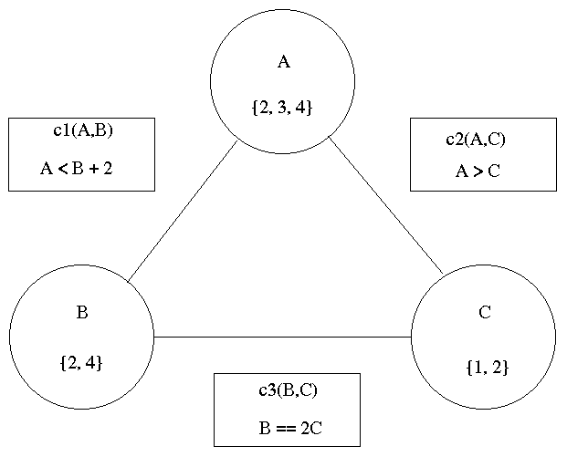
COMP-4640: Intelligent & Interactive Systems
Lecture #5

Constraint Satisfaction Search (cont.)

The search trace for our new CSP is as follows

A=2

B=2
C=1 ← solution
C=2
B=4
C=1
C=2

A=3

B=2
C=1 ← solution
C=2
B=4
C=1
C=2 ← solution

A=4

B=2

B=4

C=1
C=2 ← solution
COMP-4640: Intelligent & Interactive Systems
Lecture #5

Constraint Satisfaction Search (Forward Checking)

Is it possible to reduce the amount of thrashing further? YES! We can use a technique called Forward Checking.

Forward checking can be view as revising each uninstantiated variable with the values of each instantiated variable.

COMP-4640: Intelligent & Interactive Systems
Lecture #5

Constraint Satisfaction Search (Forward Checking cont.)

COMP-4640: Intelligent & Interactive Systems
Lecture #5

Constraint Satisfaction Search (Forward Checking cont.)

A=2 [DB={2,4}, DC={1}]
B=2 [DC={1}]
C=1 ← solution
B=4 [DC={}]
A=3 [DB={2,4}, DC={1,2}]
B=2 [DC={1}]
C=1 ← solution
B=4 [DC={2}]
C=2 ← solution
A=4 [DB={4}, DC ={1,2}]
B=4 [DC={2}]
C=2 ← solution

COMP-4640: Intelligent & Interactive Systems
Lecture #5

Constraint Satisfaction Search (Maintaining Arc Consistency)

- There is another backtrack-based algorithm that is even more efficient. It is called the maintaining arc consistency (MAC) algorithm.

- In the MAC algorithm, rather than just revising each domain corresponding with the value of each instantiated variable MAC makes the network arc-consistent with respect to the intantiated variables.

- Using MAC the search traces is as follows:

COMP-4640: Intelligent & Interactive Systems

Lecture #5

Constraint Satisfaction Search (Maintaining Arc Consistency)

A=2 [DB={2}, DC={1}]
B=2 [DC={1}]
C=1 ← solution
A=3 [DB={2,4}, DC={1,2}]
B=2 [DC={1}]
C=1 ← solution
B=4 [DC={2}]
C=2 ← solution
A=4 [DB={4}, DC={2}]
B=4 [DC={2}]
C=2 ← solution

